## CSCE 5430.001 Software Engineering (Group-9)

# Texas Online Health Care Facilities

**Group members-**

**Abdul Khader Shaik**

**Manasa V Jadda**

**Yaswanth B**

**Lalithambika**

**Namratha M**

**Lavanya K**

# Table of Contents

1. Introduction……………………………………………………………………...4

1.1. Background………………………………………………………………4

1.2. Purpose…………………………………………………………………...4

2. Requirement Analysis………………………………………………………....5

2.1. Functional Requirements…………………………………………………5

2.2. Non-functional Requirements…………………………………………….5

2.3. System Requirement specifications………………………………………6

3. Use case View…………………………………………………………………7

3.1. Identification of Actors……………………………………………….7

3.2. Graphical Depiction………………………………………………….7

3.3. Identification of Use cases and Sub use cases……………………….8

3.4. Use Case Diagram…………………………………………………...10

4. Class Diagram…………………………………………………………………11

5. System Design…………………………………………………………………12

5.1. Sample Prototypes for Our Application……………………………….12

5.2. Context Diagram…………………………………………....................16

5.3 Activity Diagram………………………………………………………17

5.4 System Architecture Diagram…………………………………………19

6. Implementation………………………………………………………………...20

7.Testing………………………………………………………………………….57

8. Deployment Diagram………………………………………………………….58

9. Jira Board………………………………………………………………………59

10.Conclusion…………………………………………………………………….60

# **Table of Figures**

Figure-1 - Use case diagram

Figure-2 - Class diagram

Figure-3 - Context diagram

Figure-4 - Activity diagram-medical test

Figure-5 - Activity diagram- schedule appointment

Figure-6 - System architecture diagram

Figure-7 - Deployment diagram

# **1. Introduction**

## **1.1. Background**

With the introduction of innovative technology, the healthcare sector is fast evolving, and one of the most significant shifts is the move toward digitalization. Patients can schedule doctor visits at their convenience with the aid of online scheduling tools. These technologies enable medical professionals to better manage patient records, organize visits, and deliver care. The ease and quality of healthcare services are now more important priorities for patients. Patients are increasingly using online platforms to schedule appointments, connect with healthcare practitioners, and access health information as cellphones and the internet have become more prevalent. Numerous medical specialties, including general practitioners, specialists, and complementary and alternative medicine practitioners, can be served via the online appointment system. This can make it simpler for patients to schedule appointments with the appropriate doctor depending on their unique needs.

## **1.2. Purpose**

The main goal of our project “Texas Online Health Appointment System” is to provide an online platform for patients to book an appointment for a checkup or for a medical test scheduling. This application provides the users with the ease to choose the location and doctor of their choice. Booking an appointment online helps in saving time and organizing their visits appropriately. This application helps ale users who wish to book an appointment online with ease.

# **2. Requirement Analysis**

## **2.1. Functional Requirements-**

Functional requirements let us know what a software product does should be specified of

|  |  |  |  |
| --- | --- | --- | --- |
| **RID** | **Requirements** | **Requirement Nature** | **Moscow** |
| R1 | Intuitive Graphical User Interface for the User and Doctor | Functional | Should Have |
| R2 | Users can schedule appointments with doctors. | Functional | Must have |
| R3 | Users can schedule appointments for medical tests. | Functional | Must have |
| R4 | User checks for the doctors in their required locations. | Functional | Must have |
| R5 | Existing Users can schedule appointments directly with the file number. | Functional | Must have |
| R6 | Doctor Login into the portal. | Functional | Must have |
| R7 | Doctors check their appointments | Functional | Must have |
| R8 | Doctors can edit and view their profiles. | Functional | Must have |
| R9 | Doctors set their available timings. | Functional | Must have |
| R10 | Staff login into their profiles. | Functional | Must have |
| R11 | Staff can check the scheduled appointments | Functional | Must have |
| R12 | Staff checks the doctor's availability. | Functional | Must have |

## **2.2. Non-functional Requirements-**

System functionality and performance cases come under non-functional requirements.

|  |  |  |  |
| --- | --- | --- | --- |
| **RID** | **Requirements** | **Requirement Nature** | **Moscow** |
| R1 | Doctor/staff login must have a Security | Non-functional | Must have |
| R2 | Webpages interactive with faster response times | Non-functional | Must have |
| R3 | Webpages must be compatible with all  browsers for user access | Non-functional | Must have |
| R4 | When a greater number of users are  scheduling appointments, it needs to be scalable. | Non-functional | Must have |
| R5 | User Information that was stored needs to be secured. | Non-functional | Must have |
| R6 | Doctor/staff details need to be secured. | Non-functional | Must have |
| R7 | Doctor/staff are able to view data quickly in  terms of performance | Non-functional | Must have |
| R8 | The Portal needs to be compatible with all software  and hardware configurations. | Non-functional | Must have |

**Table 2**

## **2.3. System Requirement Specifications:**

* **Hardware requirements-**

Minimum: Pentium IV Processor with 1.2GHZ

Hard Disk: 500GB

Ram: 2GB

Display: LCD Monitor

* **Platform Specification-**

Operating system: Any Operating System after WINDOWS 2000

Front End: HTML, CSS

Back End: Java, Spring boot

Database: My SQL

Software: Eclipse, Visual Studio

# **3. Use case View**

## **3.1. IDENTIFICATION OF ACTORS:**

Actors represent system users. They are NOT part of the system. They represent anyone or anything that interacts with (input to or receive output from) the system. An actor is someone or something that:

Interacts with or uses the system.

Provides input to and receives information from the system.

Is external to the system and has no control over the use cases.

Actors are discovered by examining:

Who directly uses the system?

Who is responsible for maintaining the system?

External hardware used by the system.

Other systems that need to interact with the system.

The needs of the actor are used to develop use cases. This ensures that the system will be what the user expected.

## **3.2. GRAPHICAL DEPICTION:**

An actor is a stereotype of a class and is depicted as a “stickman” on a use-case diagram. For example:

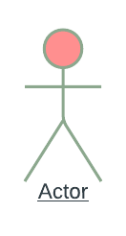

Naming:

The name of the actor is displayed below the icon.

For our use case diagram following are the Actors identified:

1. User

2.Doctor

3. Supporting staff

* User includes actions like scheduling appointments and viewing the doctors at available locations.
* The doctor must log in to check appointments and set the available times and actions such as profile editing.
* Supporting staff also log in to the portal and do actions like editing and viewing profile, and checking scheduled appointments and doctor schedules.

## **3.3. IDENTIFICATION OF USE-CASES AND SUB-USE-CASES**

Use-cases diagrams graphically represent system behavior (use cases). These diagrams present a high-level view of how the system is used viewed from an outsider’s (actor’s) perspective. A use-case diagram may contain all or some of the use cases of a system.

A use-case diagram can contain:

* Actors (“things” outside the system)
* Use cases (system boundaries identifying what the system should do)
* Interactions or relationships between actors and use cases in the system including the associations, dependencies, and generalizations.
* Use-case diagrams can be used during analysis to capture the system requirements and to understand how the system should work. During the design phase, you can use use-case diagrams to specify the behavior of the system as implemented.
* In its simple form, a use case can be described as a specific way of using the system from a user’s (actor’s) perspective. A more detailed description might characterize a use case as:
* A pattern of behavior the system exhibits
* A sequence of related transactions performed by an actor and the system.
* Delivering something of value to the actor

Use case provides a means to:

* Capture system requirements.
* Communicate with the end-users and domain experts.
* Test the system.

Use cases are best discovered by examining the actors and defining what the actor will be able to do with the system. Since all the needs of a system typically cannot be covered in one use case, it is usual to have a collection of use cases. Together this use case collection specifies all the ways the system.

The use case is a sequence of transactions performed by a system that yields a measurable result of values for a particular actor. The use cases are all the ways the system may be used.

The UML notation for the use case is an ellipse.

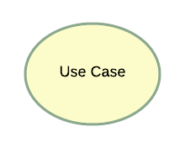

1. **Graphical Depiction:**

An association relationship is an orthogonal or straight solid line with an arrow at one end:

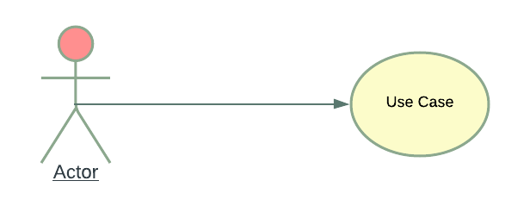

1. **Dependency Relationship:**

A dependency is a relationship between two model elements in which a change to one model element will affect the other model element. Use a dependency relationship to connect model elements with the same level of meaning. Typically, on class diagrams, a dependency relationship indicates that the operations of the client invoke the operations of the supplier.

* There are two types of dependency relationships that may exist between use cases: *include relationship* and *extend the relationship.*

1. «extend» is used when you wish to show that a use case provides additional functionality that may be required in another use case.
2. «include» applies when there is a sequence of behavior that is used frequently in several use cases, and you want to avoid copying the same description of it into each use case in which it is used.

## **3.4 Use Case Diagram**

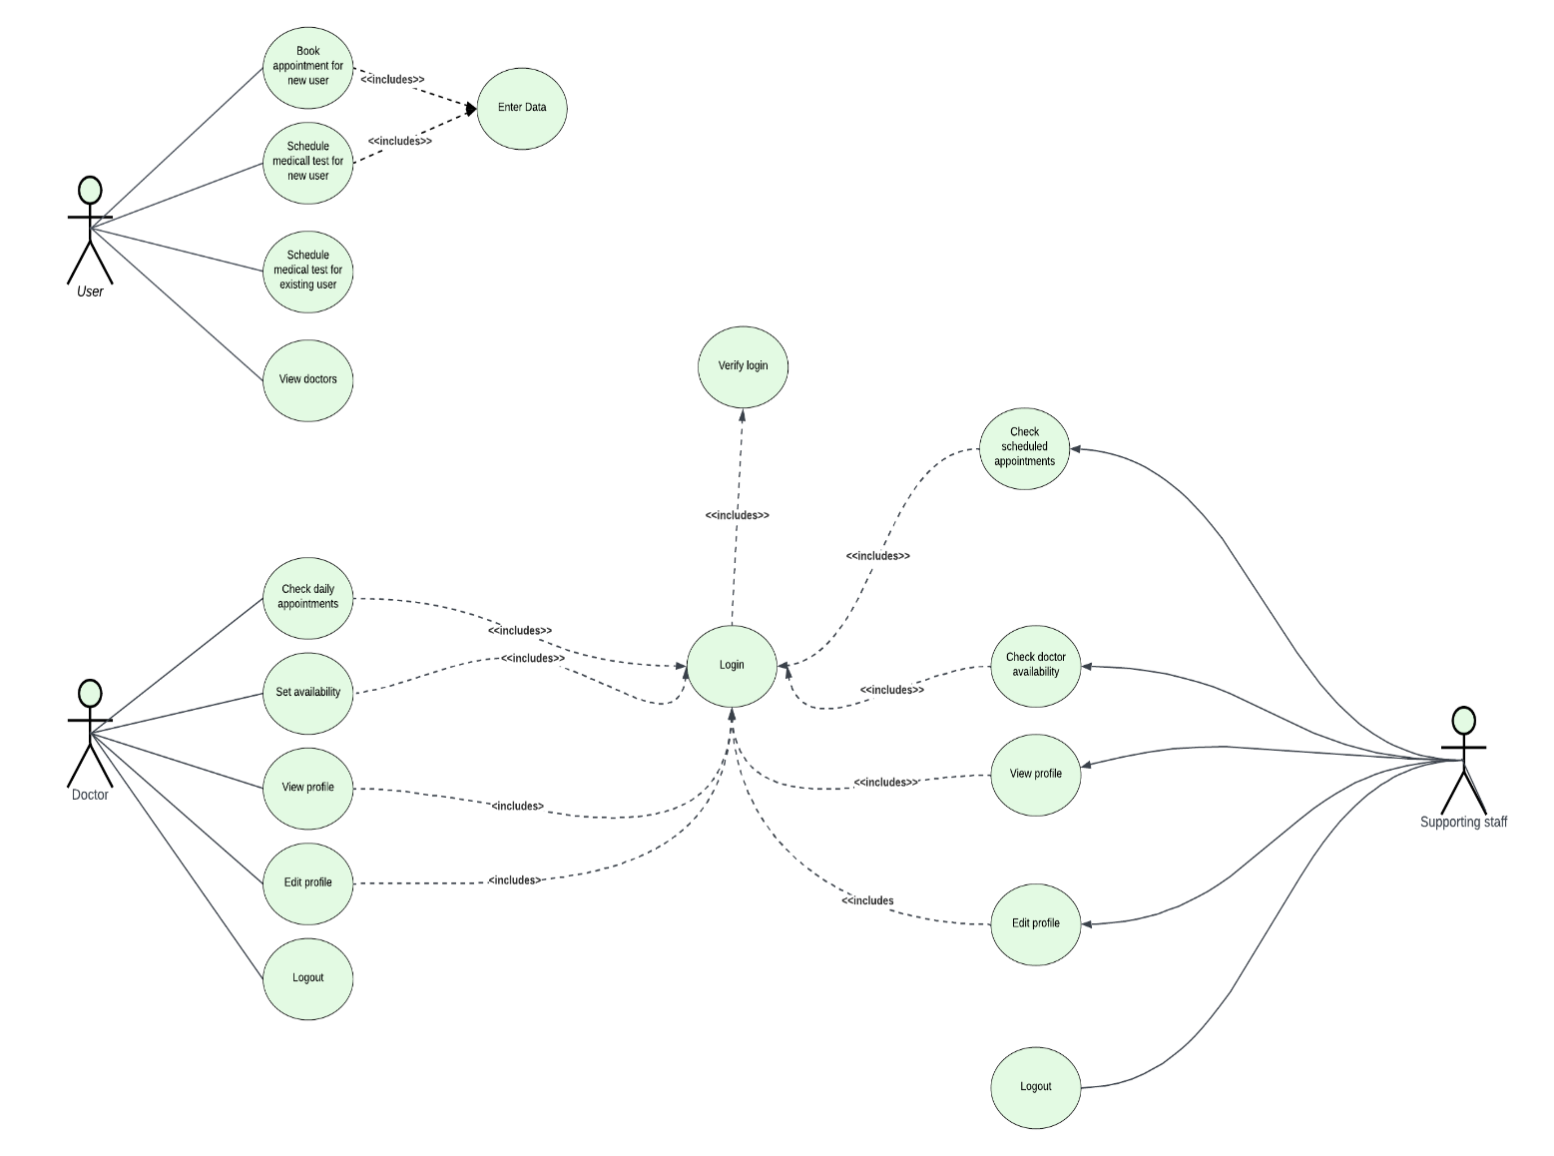

Figure-1

# **4.Class Diagram**

The class diagrams are the system or subsystem's blueprints. Class diagrams are useful for modeling the system's constituent parts, showing the relationships among them, and describing the functions and services that each performs. In many phases of system design, class diagrams are helpful.

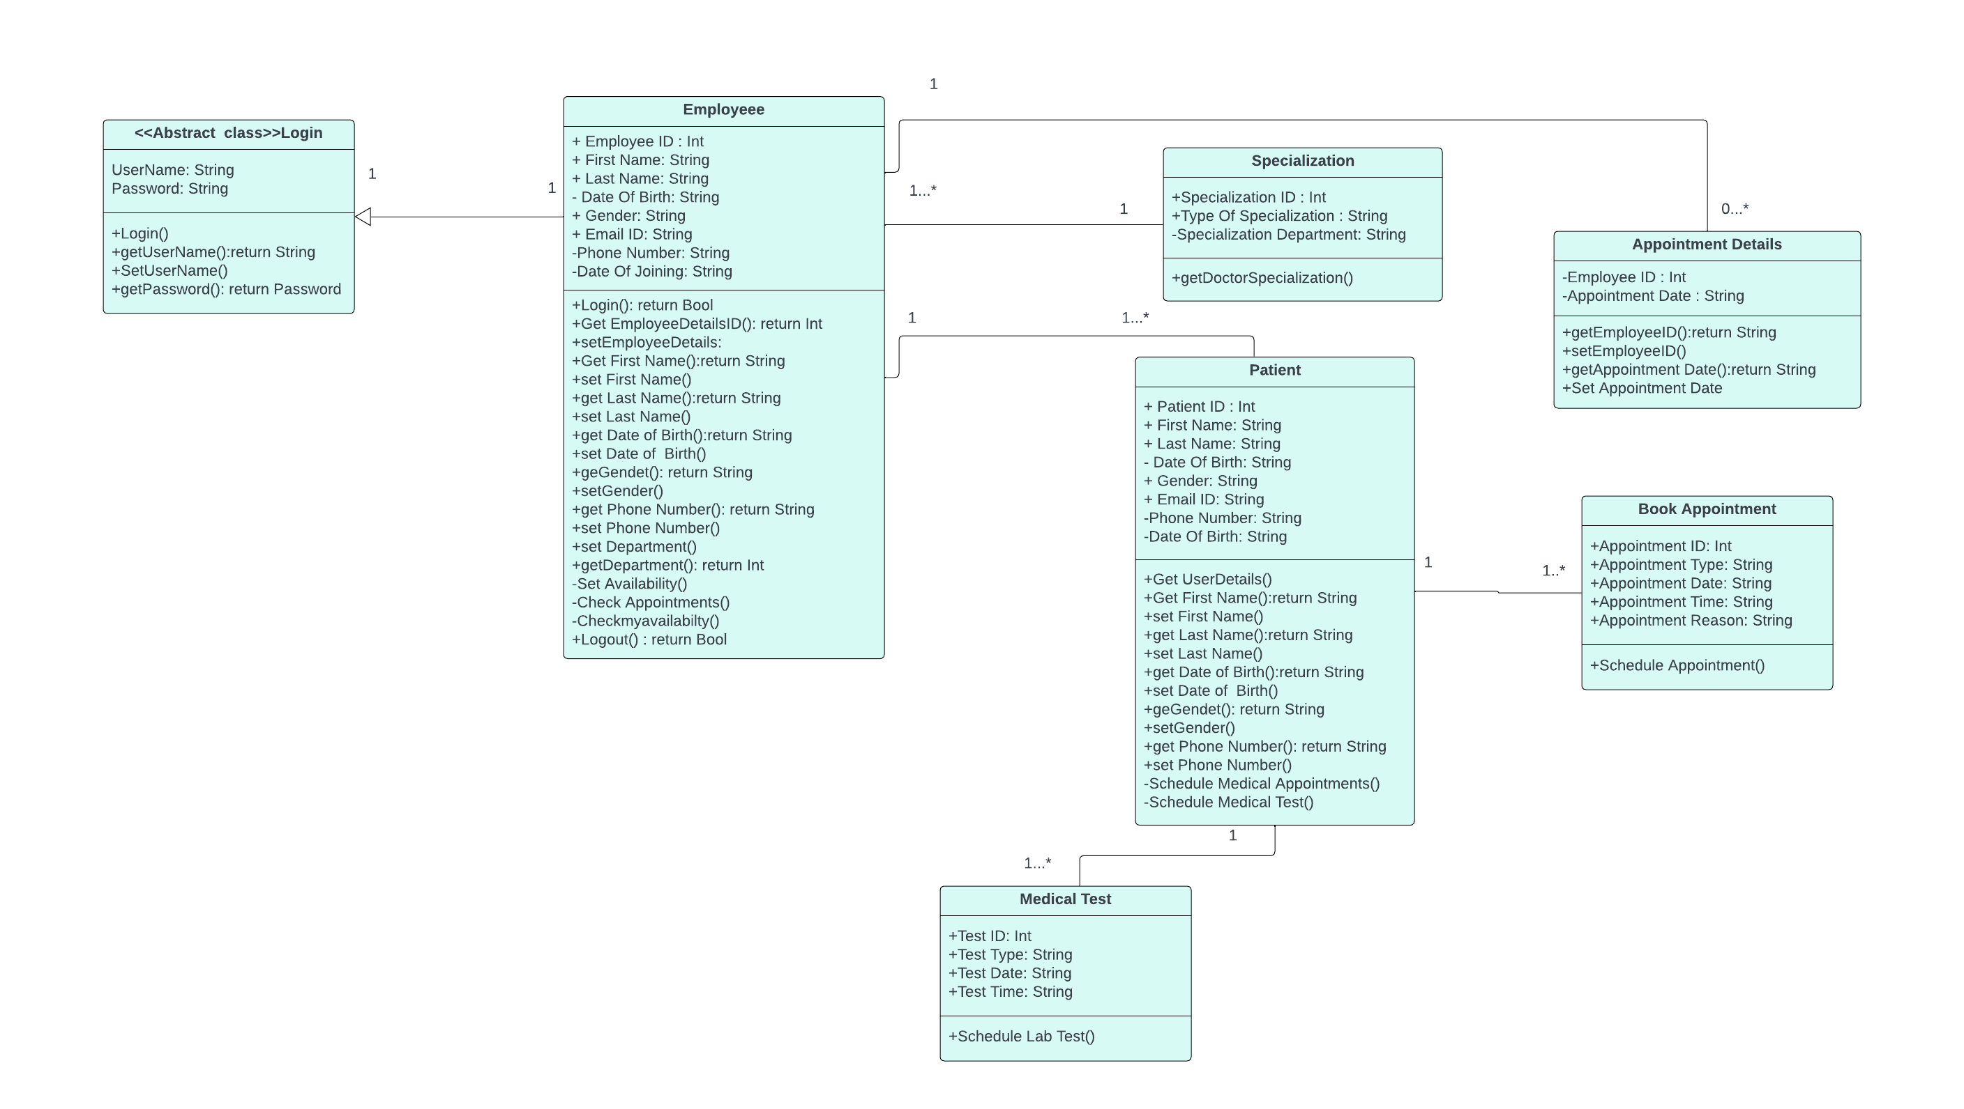

**Figure-2**

# **5. System Design**

## **5.1. SAMPLE PROTOTYPES FOR OUR APPLICATION**

1) In software development, a prototype is a rudimentary working model of a product or information system, usually built for demonstration purposes or as part of the development process. In the systems development life cycle (SDLC) Prototyping Model, a basic version of the system is built, tested, and then reworked as necessary until an acceptable prototype is finally achieved from which the complete system or product can now be developed.

2) In prototype-based programming, a prototype is an original object; new objects are created by copying the prototype.

3) In hardware design, a prototype is a "hand-built" model that represents a manufactured (easily replicable) product sufficiently for designers to visualize and test the design.

Here are our sample prototypes for our application.

**1. Home Page**

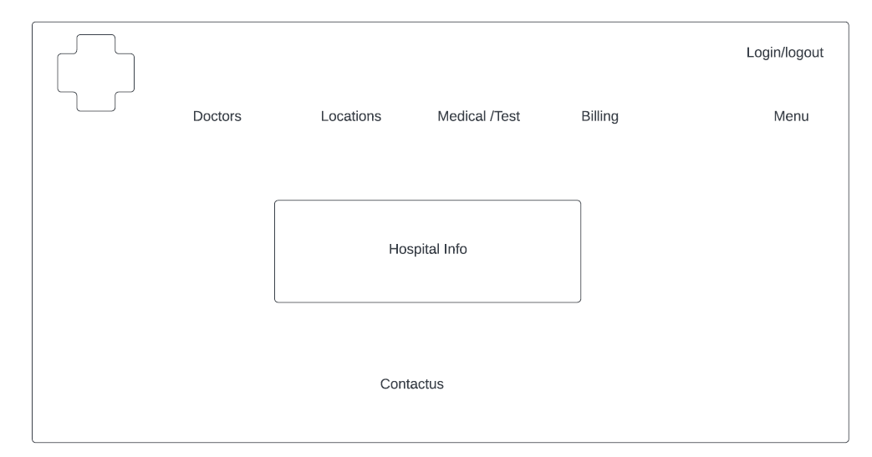

**2. Menu Page**

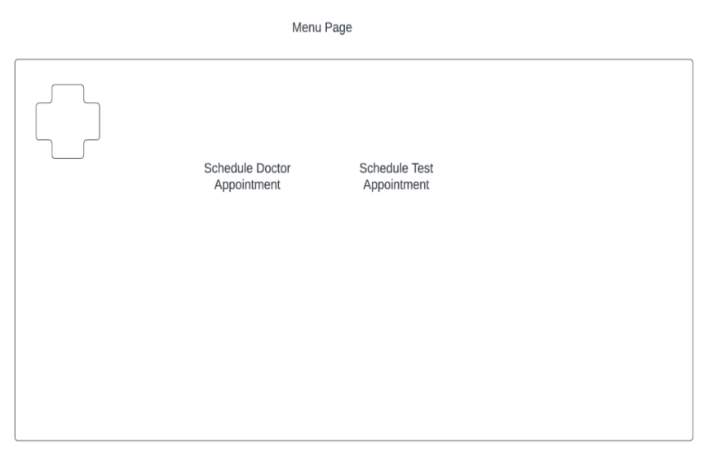

**3. Our Doctor’s Page**

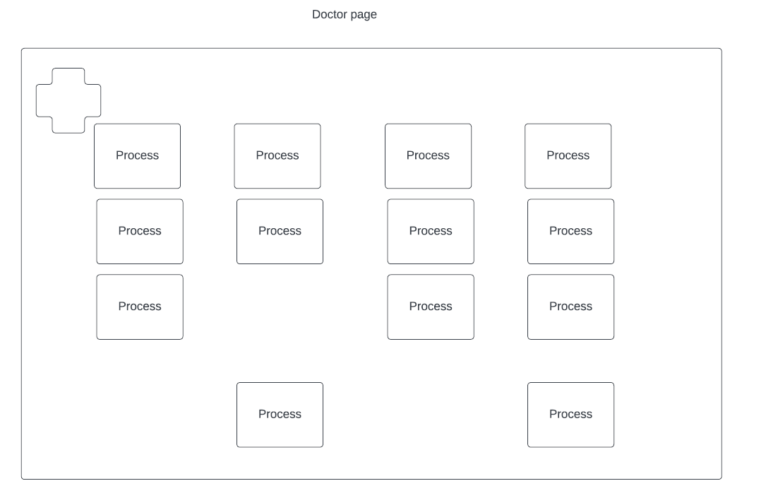

**4. Doctor’s Information Page**

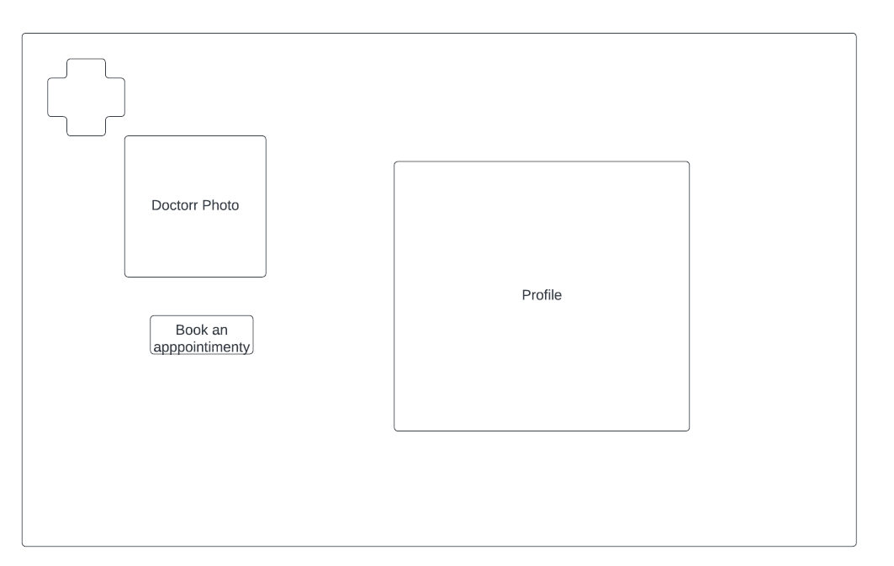

**5. Our Locations Page**

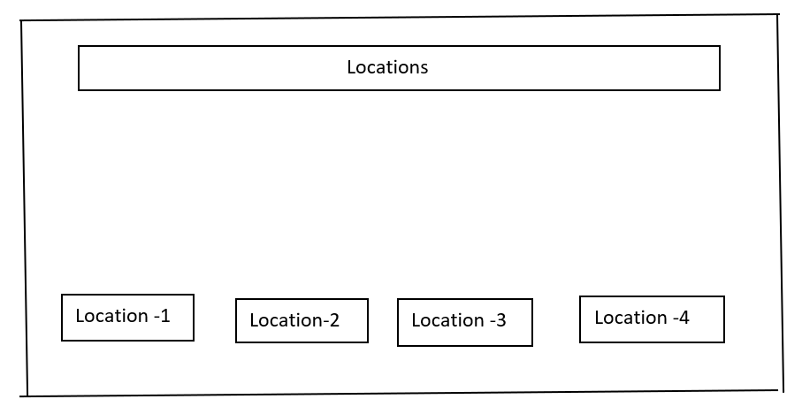

**6. Doctor Login Page**

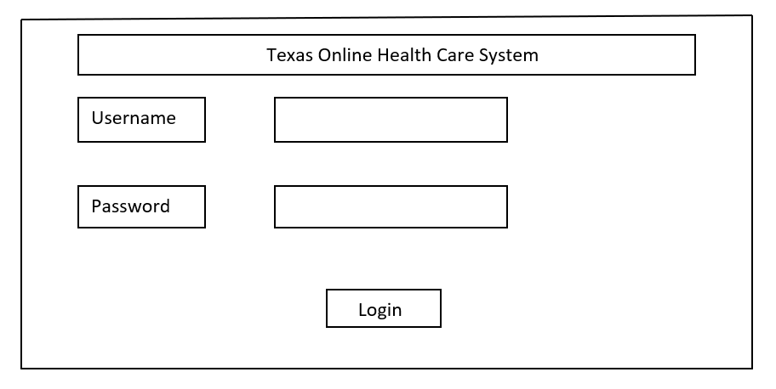

**7. Book an Appointment Page**

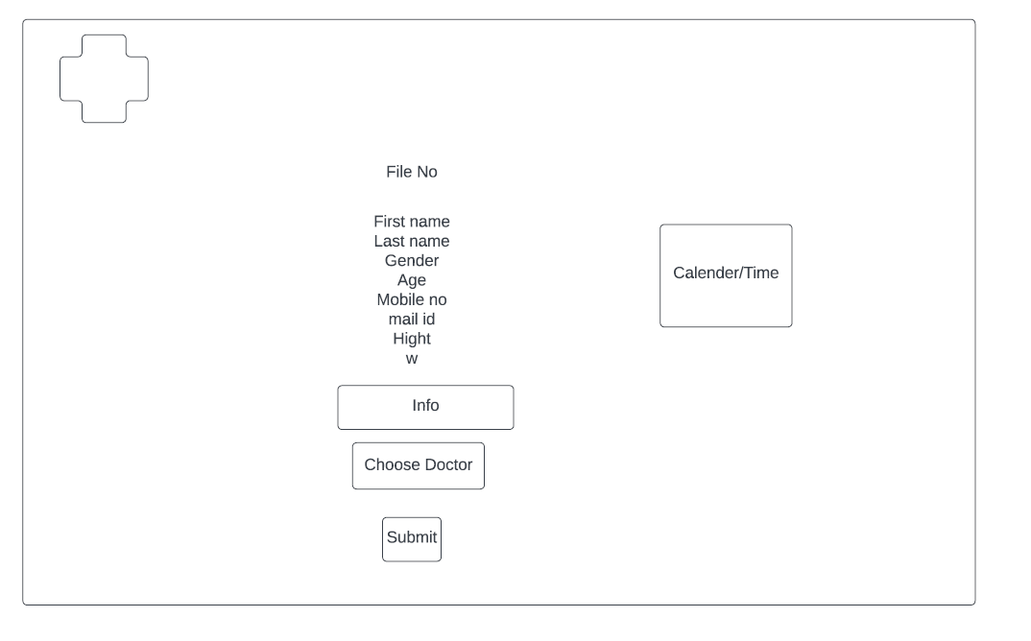

## **5.2. Context diagram**

Context diagram represents the view of the system on a big level. It also has boundaries and defines system functionalities that represent the data flow of the system.

Context diagram has the components includes:

* Product:

This system's representation is defined as an entity as a product in as rectangle format in the center below.

* Entities or agents:

This function represents a system, entities with functionalities of the product designed. This can be represented with rectangles.

* Flowlines:

Flowlines depict data flows between entities and products. This can be represented with arrow lines.

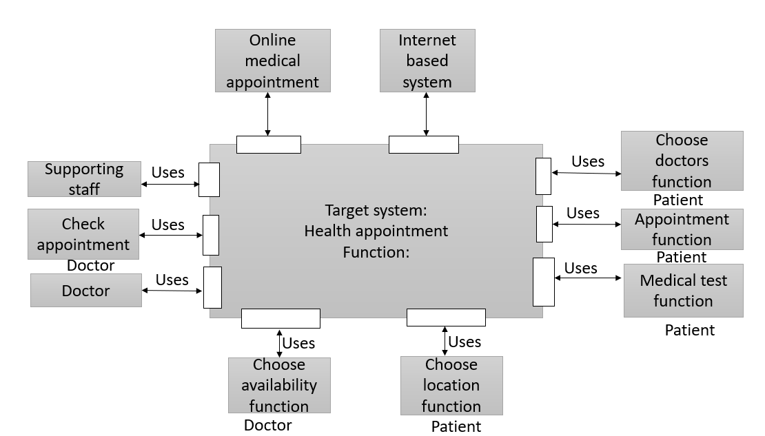

**Figure-3**

## **5.3. Activity diagram**

The activity diagram represents the flow of the system developed. It usually depicts process flow with functions and is easy to implement with this path.

Components of the activity diagram-

* Start node: The start node represents the beginning of the activity that is represented with a black circle at the beginning of the diagram.
* Activity: The activity node depicts the functionality of the system that includes the process involved. It is represented with a rectangle.
* Decision node: The decision node has two paths with conditions that give assorted options. This is represented by the container as a rhombus.
* Connector: The connector symbol connects processes and decision nodes. This can be represented with arrow lines.
* End node: The end node represents the end of the diagram represented with outlined black circle.

Activity diagram for a user to book a medical test

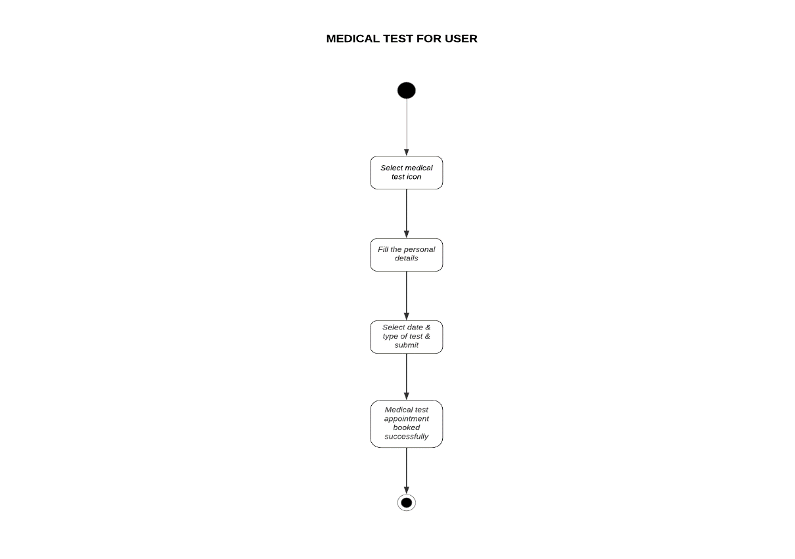

**Figure-4**

Activity diagram for user to schedule an appointment

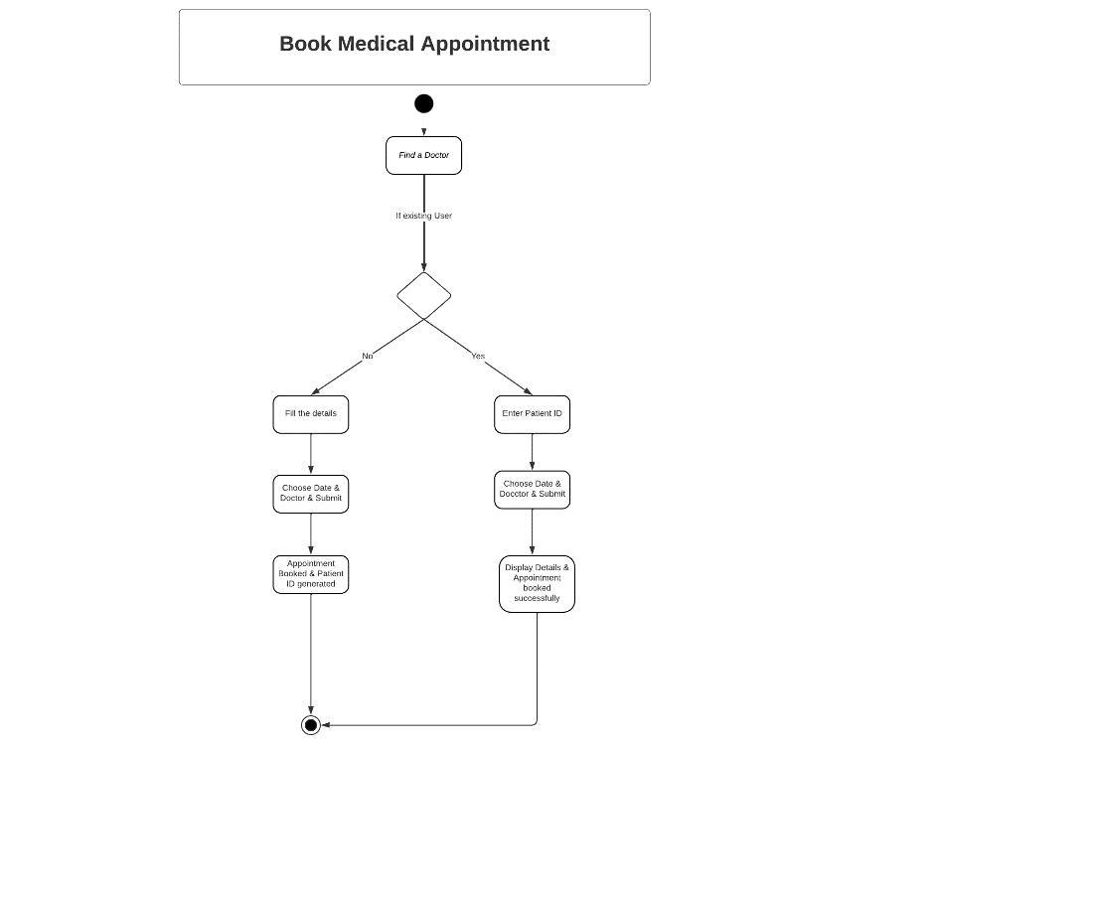

**Figure-5**

## **5.4 System Architecture diagram**

The system architecture diagram is the abstract view of the system components that represent system behavior. This diagram helps for better collaborations and understanding the business requirements.

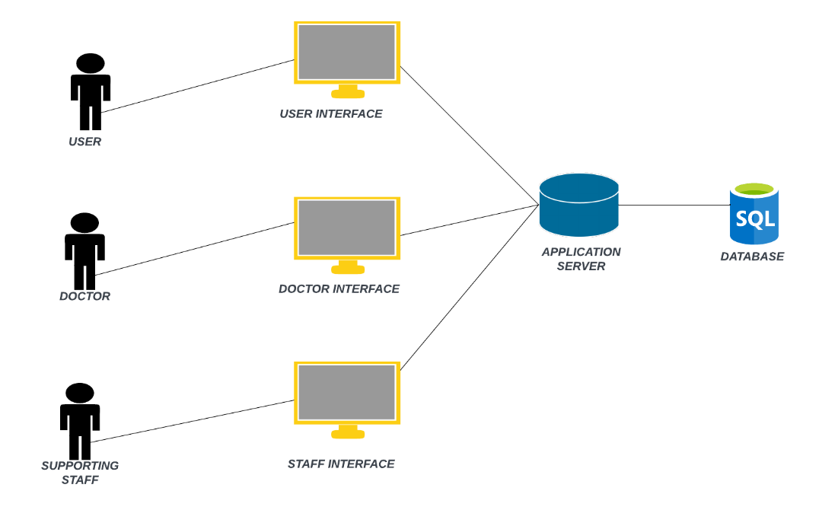

**Figure-6**

# **6. Implementation**

**Hospital_management (API):**

org.hospital.mgmt.HospitalManagementApplication

public static void main(String[] args) {

SpringApplication.run(HospitalManagementApplication.class, args);

}

org.hospital.mgmt.controller

**@Controller**

@RequestMapping(path = "/department")

public class DepartmentController {

@Autowired

private DepartmentRepository departmentRepository;

@GetMapping(path = "/all")

public @ResponseBody Iterable<Department> getAllUsers() {

return departmentRepository.findAll();

}

}

**@Controller**

@RequestMapping(path = "/employee")

public class EmployeeController {

@Autowired

private EmployeeRepository employeeRepository;

@Autowired

private EmployeeTypeRepository employeeTypeRepository;

@Autowired

private EmployeeDetailsRepository employeeDetailsRepository;

@Autowired

private AppointmentDetailsRepository appointmentDetailsRepository;

@PostMapping(path = "/add")

@Transactional

public @ResponseBody String addNewUser(@RequestBody EmployeeRequest employeeRequest) {

Employee emp = new Employee();

emp.setFirstName(employeeRequest.getFirstName());

emp.setLastName(employeeRequest.getLastName());

emp.setDateOfBirth(employeeRequest.getDateOfBirth());

emp.setGender(employeeRequest.getGender());

emp.setPhoneNumber(employeeRequest.getPhoneNumber());

DateFormat dateFormat = new SimpleDateFormat("yyyy-mm-dd hh:mm:ss");

String currDt = dateFormat.format(new Date(Calendar.getInstance().getTimeInMillis()));

emp.setCreatedOn(currDt);

emp = employeeRepository.save(emp);

EmployeeDetails empDetails = new EmployeeDetails();

EmployeeType employeeType = new EmployeeType();

employeeType.setEmployeeTypeID(employeeRequest.getRoleID());

empDetails.setEmployeeTypeID(employeeType);

Department department = new Department();

department.setDepartmentID(employeeRequest.getDepartmentID());

empDetails.setDepartmentID(department);

empDetails.setEmployeeID(emp);

employeeDetailsRepository.save(empDetails);

return "Saved";

}

@GetMapping(path = "/all")

public @ResponseBody Iterable<Employee> getAllEmployees() {

return employeeRepository.findAll();

}

@GetMapping(path = "/types")

public @ResponseBody Iterable<EmployeeType> getEmployeeTypes() {

return employeeTypeRepository.findAll();

}

@GetMapping(path = "/type/{employeeTypeID}/dept/{departmentID}")

public @ResponseBody Iterable<Employee> getEmployeesByDepartment(@PathVariable Integer employeeTypeID, @PathVariable Integer departmentID) {

Department department = new Department();

department.setDepartmentID(departmentID);

EmployeeType employeeType = new EmployeeType();

employeeType.setEmployeeTypeID(employeeTypeID);

List<EmployeeDetails> employeeDetailsList = employeeDetailsRepository.findByDepartmentIDAndEmployeeTypeID(department, employeeType);

List<Integer> employeeIds = employeeDetailsList.stream()

.map(EmployeeDetails::getEmployeeID)

.map(Employee::getEmployeeID)

.collect(Collectors.toList());

return employeeRepository.findByEmployeeIDIn(employeeIds);

}

@SuppressWarnings({ "rawtypes", "unchecked" })

@PostMapping(path = "/login")

public @ResponseBody ResponseEntity<Employee> login(@RequestBody LoginRequest request ) {

Employee employee = employeeRepository.findByEmailIDAndPassword(request.getUsername(), request.getPassword());

if (employee != null) {

return new ResponseEntity(employee, HttpStatus.OK);

} else {

return new ResponseEntity(HttpStatus.NOT_FOUND);

}

}

@GetMapping(path = "/{employeeID}/appointments")

public @ResponseBody Iterable<AppointmentDetails> getEmployeeAppointments(@PathVariable Integer employeeID) {

Employee employee = new Employee();

employee.setEmployeeID(employeeID);

return appointmentDetailsRepository.findByEmployeeID(employee);

}

@PostMapping(path = "/appointments/date")

public @ResponseBody Iterable<AppointmentDetails> getEmployeeAppointments(@RequestBody AppointmentRequest appointmentRequest) {

Employee employee = new Employee();

employee.setEmployeeID(appointmentRequest.getEmployeeID());

Date date = Date.from(Instant.parse(appointmentRequest.getAppointmentDate()));

java.sql.Date aptDate = new java.sql.Date(date.getTime());

return appointmentDetailsRepository.findByEmployeeIDAndDate(employee, aptDate.toString());

}

}

**@Controller**

@RequestMapping(path = "/labtests")

public class LabController {

@Autowired

private LabtestRepository labtestRepository;

@Autowired

private PatientRepository patientRepository;

@Autowired

private AppointmentDetailsRepository appointmentDetailsRepository;

@GetMapping(path = "/all")

public @ResponseBody Iterable<LabTest> getAllUsers() {

return labtestRepository.findAll();

}

@PostMapping(path="/book")

public @ResponseBody Integer bookLabTest(@RequestBody LabTestAppointment testApptDetails) throws ParseException {

AppointmentDetails appointmentDetails = new AppointmentDetails();

SimpleDateFormat format = new SimpleDateFormat("yyyy-MM-dd HH:mm:ss");

List<Integer> labTests = testApptDetails.getLabTestIDs();

if(null == testApptDetails.getPatientID()) {

Patient patient = new Patient();

patient.setFirstName(testApptDetails.getFirstName());

patient.setLastName(testApptDetails.getLastName());

patient.setGender(testApptDetails.getGender());

patient.setEmailID(testApptDetails.getEmailID());

Date dateofBirth = Date.from(Instant.parse(testApptDetails.getDateOfBirth()));

patient.setDateOfBirth(format.format(dateofBirth));

patient.setPhoneNumber(testApptDetails.getPhoneNumber());

patient.setAddress(testApptDetails.getAddress());

patient.setZipCode(testApptDetails.getZipCode());

Patient newPatient = patientRepository.save(patient);

appointmentDetails.setPatientID(newPatient);

} else {

Patient patient = new Patient();

patient.setPatientID(testApptDetails.getPatientID());

appointmentDetails.setPatientID(patient);

}

Date appointmentDate = Date.from(Instant.parse(testApptDetails.getAppointmentDate()));

appointmentDetails.setDate(format.format(appointmentDate));

for(int i=0; i<labTests.size(); i++) {

LabTest labTest = new LabTest();

labTest.setLabTestID(labTests.get(i));

appointmentDetails.setLabTestID(labTest);

if(i==0) {

appointmentDetails = appointmentDetailsRepository.save(appointmentDetails);

}

appointmentDetailsRepository.save(appointmentDetails);

}

return appointmentDetails.getAppointmentID();

}

}

**@Controller**

@RequestMapping(path = "/patient")

public class PatientController {

@Autowired

private PatientRepository patientRepository;

@Autowired

private AppointmentDetailsRepository appointmentDetailsRepository;

@SuppressWarnings({ "unchecked", "rawtypes" })

@PostMapping(path = "/byID")

public @ResponseBody ResponseEntity<Patient> getPatientByID(@RequestBody String id ) {

Optional<Patient> patient = patientRepository.findById(Integer.valueOf(id));

if (patient.isPresent()) {

return new ResponseEntity(patient.get(), HttpStatus.OK);

} else {

return new ResponseEntity(HttpStatus.NOT_FOUND);

}

}

@PostMapping(path="/bookAppointment")

public @ResponseBody AppointmentDetails bookAppointment(@RequestBody LabTestAppointment testApptDetails) throws ParseException {

AppointmentDetails appointmentDetails = new AppointmentDetails();

SimpleDateFormat format = new SimpleDateFormat("yyyy-MM-dd HH:mm:ss");

if(null == testApptDetails.getPatientID()) {

Patient patient = new Patient();

patient.setFirstName(testApptDetails.getFirstName());

patient.setLastName(testApptDetails.getLastName());

patient.setGender(testApptDetails.getGender());

patient.setEmailID(testApptDetails.getEmailID());

Date dateofBirth = Date.from(Instant.parse(testApptDetails.getDateOfBirth()));

patient.setDateOfBirth(format.format(dateofBirth));

patient.setPhoneNumber(testApptDetails.getPhoneNumber());

patient.setAddress(testApptDetails.getAddress());

patient.setZipCode(testApptDetails.getZipCode());

patient.setCreatedBy("SYSTEM");

patient.setCreatedOn(new java.sql.Date(new Date().getTime()));

Patient newPatient = patientRepository.save(patient);

appointmentDetails.setPatientID(newPatient);

} else {

Patient patient = new Patient();

patient.setPatientID(testApptDetails.getPatientID());

appointmentDetails.setPatientID(patient);

}

Date appointmentDate = Date.from(Instant.parse(testApptDetails.getAppointmentDate()));

appointmentDetails.setDate(format.format(appointmentDate));

Employee employee = new Employee();

employee.setEmployeeID(testApptDetails.getEmployeeID());

appointmentDetails.setEmployeeID(employee);

return appointmentDetailsRepository.save(appointmentDetails);

}

}

**org.hospital.mgmt.repository**

public interface AppointmentDetailsRepository extends CrudRepository<AppointmentDetails, Integer> {

List<AppointmentDetails> findByEmployeeID(Employee employeeID);

List<AppointmentDetails> findByEmployeeIDAndDate(Employee employeeID, String appointmentDate);

}

public interface DepartmentRepository extends CrudRepository<Department, Integer> {

}

public interface EmployeeDetailsRepository extends CrudRepository<EmployeeDetails, Integer> {

List<EmployeeDetails> findByEmployeeTypeID(EmployeeType employeeTypeID);

List<EmployeeDetails> findByDepartmentID(Department departmentID);

List<EmployeeDetails> findByDepartmentIDAndEmployeeTypeID(Department departmentID, EmployeeType employeeTypeID);

}

public interface EmployeeRepository extends CrudRepository<Employee, Integer> {

Iterable<Employee> findByEmployeeID(Integer employeeTypeID);

Iterable<Employee> findByEmployeeIDIn(List<Integer> employeeIDs);

Employee findByEmailIDAndPassword(String emailID, String password);

}

public interface EmployeeTypeRepository extends CrudRepository<EmployeeType, Integer> {

}

public interface LabtestRepository extends CrudRepository<LabTest, Integer> {

}

public interface PatientRepository extends CrudRepository<Patient, Integer> {

Optional<Patient> findById(Integer id);

}

**org.hospital.mgmt.model**

public class AppointmentRequest {

private Integer employeeID;

private String appointmentDate;

public Integer getEmployeeID() {

return employeeID;

}

public void setEmployeeID(Integer employeeID) {

this.employeeID = employeeID;

}

public String getAppointmentDate() {

return appointmentDate;

}

public void setAppointmentDate(String appointmentDate) {

this.appointmentDate = appointmentDate;

}

}

public class EmployeeRequest {

private Integer employeeDetailsID;

private String firstName;

private String lastName;

private String dateOfBirth;

private String gender;

private String phoneNumber;

private Integer roleID;

private Date createdOn;

private Date ModifiedOn;

private Integer departmentID;

public Integer getEmployeeDetailsID() {

return employeeDetailsID;

}

public void setEmployeeDetailsID(Integer employeeDetailsID) {

this.employeeDetailsID = employeeDetailsID;

}

public String getFirstName() {

return firstName;

}

public void setFirstName(String firstName) {

this.firstName = firstName;

}

public String getLastName() {

return lastName;

}

public void setLastName(String lastName) {

this.lastName = lastName;

}

public String getDateOfBirth() {

return dateOfBirth;

}

public void setDateOfBirth(String dateOfBirth) {

this.dateOfBirth = dateOfBirth;

}

public String getGender() {

return gender;

}

public void setGender(String gender) {

this.gender = gender;

}

public String getPhoneNumber() {

return phoneNumber;

}

public void setPhoneNumber(String phoneNumber) {

this.phoneNumber = phoneNumber;

}

public Integer getRoleID() {

return roleID;

}

public void setRoleID(Integer roleID) {

this.roleID = roleID;

}

public Date getCreatedOn() {

return createdOn;

}

public void setCreatedOn(Date createdOn) {

this.createdOn = createdOn;

}

public Date getModifiedOn() {

return ModifiedOn;

}

public void setModifiedOn(Date modifiedOn) {

ModifiedOn = modifiedOn;

}

public Integer getDepartmentID() {

return departmentID;

}

public void setDepartmentID(Integer departmentID) {

this.departmentID = departmentID;

}

}

public class LabTestAppointment {

private String firstName;

private String lastName;

private String dateOfBirth;

private String gender;

private String phoneNumber;

private String appointmentDate;

private Date createdOn;

private Date modifiedOn;

private Integer patientID;

private String emailID;

private String address;

private String zipCode;

private List<Integer> labTestIDs;

private Integer employeeID;

public String getZipCode() {

return zipCode;

}

public void setZipCode(String zipCode) {

this.zipCode = zipCode;

}

public String getEmailID() {

return emailID;

}

public void setEmailID(String emailID) {

this.emailID = emailID;

}

public List<Integer> getLabTestIDs() {

return labTestIDs;

}

public void setLabTestIDs(List<Integer> labTestIDs) {

this.labTestIDs = labTestIDs;

}

public String getFirstName() {

return firstName;

}

public void setFirstName(String firstName) {

this.firstName = firstName;

}

public String getLastName() {

return lastName;

}

public void setLastName(String lastName) {

this.lastName = lastName;

}

public String getDateOfBirth() {

return dateOfBirth;

}

public void setDateOfBirth(String dateOfBirth) {

this.dateOfBirth = dateOfBirth;

}

public String getGender() {

return gender;

}

public void setGender(String gender) {

this.gender = gender;

}

public String getPhoneNumber() {

return phoneNumber;

}

public void setPhoneNumber(String phoneNumber) {

this.phoneNumber = phoneNumber;

}

public String getAppointmentDate() {

return appointmentDate;

}

public void setAppointmentDate(String appointmentDate) {

this.appointmentDate = appointmentDate;

}

public Date getCreatedOn() {

return createdOn;

}

public void setCreatedOn(Date createdOn) {

this.createdOn = createdOn;

}

public Date getModifiedOn() {

return modifiedOn;

}

public void setModifiedOn(Date modifiedOn) {

this.modifiedOn = modifiedOn;

}

public Integer getPatientID() {

return patientID;

}

public void setPatientID(Integer patientID) {

this.patientID = patientID;

}

public Integer getEmployeeID() {

return employeeID;

}

public void setEmployeeID(Integer employeeID) {

this.employeeID = employeeID;

}

public String getAddress() {

return address;

}

public void setAddress(String address) {

this.address = address;

}

}

public class LoginRequest {

private String username;

private String password;

public String getUsername() {

return username;

}

public void setUsername(String username) {

this.username = username;

}

public String getPassword() {

return password;

}

public void setPassword(String password) {

this.password = password;

}

}

**package org.hospital.mgmt.entity;**

@Entity

public class AppointmentDetails {

@Id

@GeneratedValue(strategy=GenerationType.IDENTITY)

@Column(name = "AppointmentID")

private Integer appointmentID;

@JoinColumn(name = "EmployeeID")

@OneToOne(targetEntity = Employee.class, cascade = CascadeType.MERGE)

private Employee employeeID;

@Column(name = "AppointmentDate")

private String date;

@JoinColumn(name = "PatientID")

@OneToOne(targetEntity = Patient.class)

private Patient patientID;

@JoinColumn(name = "LabTestID")

@ManyToOne(targetEntity = LabTest.class)

private LabTest labTestID;

public Integer getAppointmentID() {

return appointmentID;

}

public void setAppointmentID(Integer appointmentID) {

this.appointmentID = appointmentID;

}

public Employee getEmployeeID() {

return employeeID;

}

public void setEmployeeID(Employee employeeID) {

this.employeeID = employeeID;

}

public String getDate() {

return date;

}

public void setDate(String date) {

this.date = date;

}

public Patient getPatientID() {

return patientID;

}

public void setPatientID(Patient patientID) {

this.patientID = patientID;

}

public LabTest getLabTestID() {

return labTestID;

}

public void setLabTestID(LabTest labTestID) {

this.labTestID = labTestID;

}

@Override

public String toString() {

return "AppointmentDetails [appointmentID=" + appointmentID + ", employeeID=" + employeeID + ", date=" + date

+ ", patientID=" + patientID + ", labTestID=" + labTestID + "]";

}

}

**@Entity**

public class BillDetails {

@Id

@GeneratedValue(strategy=GenerationType.IDENTITY)

@Column(name = "BillID")

private Integer billID;

@JoinColumn(name = "LabTestID")

@OneToOne(targetEntity = LabTest.class, cascade = CascadeType.MERGE)

private Integer labTestID;

@Column(name = "Quantity")

private Integer quantity;

@Column(name = "BillingDate")

private String billingDate;

@Column(name = "BillRegNo")

private Integer billRegNo;

public Integer getBillID() {

return billID;

}

public void setBillID(Integer billID) {

this.billID = billID;

}

public Integer getLabTestID() {

return labTestID;

}

public void setLabTestID(Integer labTestID) {

this.labTestID = labTestID;

}

public Integer getQuantity() {

return quantity;

}

public void setQuantity(Integer quantity) {

this.quantity = quantity;

}

public String getBillingDate() {

return billingDate;

}

public void setBillingDate(String billingDate) {

this.billingDate = billingDate;

}

public Integer getBillRegNo() {

return billRegNo;

}

public void setBillRegNo(Integer billRegNo) {

this.billRegNo = billRegNo;

}

@Override

public String toString() {

return "BillDetails [billID=" + billID + ", labTestID=" + labTestID + ", quantity=" + quantity

+ ", billingDate=" + billingDate + ", billRegNo=" + billRegNo + "]";

}

}

@Entity

public class Department {

@Id

@GeneratedValue(strategy=GenerationType.IDENTITY)

@Column(name = "DepartmentID")

private Integer departmentID;

@Column(name = "DepartmentName")

private String departmentName;

public Integer getDepartmentID() {

return departmentID;

}

public void setDepartmentID(Integer departmentID) {

this.departmentID = departmentID;

}

public String getDepartmentName() {

return departmentName;

}

public void setDepartmentName(String departmentName) {

this.departmentName = departmentName;

}

}

**@Entity**

public class Employee {

@Id

@GeneratedValue(strategy=GenerationType.IDENTITY)

@Column(name = "EmployeeID")

private Integer employeeID;

@Column(name = "EmployeeNumber")

private Integer employeeNumber;

@Column(name = "FirstName")

private String firstName;

@Column(name = "LastName")

private String lastName;

@Column(name = "DateOfBirth")

private String dateOfBirth;

@Column(name = "Gender")

private String gender;

@Column(name = "PhoneNumber")

private String phoneNumber;

@Column(name = "EmailID")

private String emailID;

@Column(name = "Password")

private String password;

@Column(name = "DateOfJoining")

private String dateOfJoining;

@Column(name = "Address")

private String address;

@Column(name = "ZipCode")

private String zipCode;

@Column(name = "CreatedBy")

private String createdBy;

@Column(name = "CreatedOn")

private String createdOn;

public Integer getEmployeeID() {

return employeeID;

}

public void setEmployeeID(Integer employeeID) {

this.employeeID = employeeID;

}

public Integer getEmployeeNumber() {

return employeeNumber;

}

public void setEmployeeNumber(Integer employeeNumber) {

this.employeeNumber = employeeNumber;

}

public String getFirstName() {

return firstName;

}

public void setFirstName(String firstName) {

this.firstName = firstName;

}

public String getLastName() {

return lastName;

}

public void setLastName(String lastName) {

this.lastName = lastName;

}

public String getDateOfBirth() {

return dateOfBirth;

}

public void setDateOfBirth(String dateOfBirth) {

this.dateOfBirth = dateOfBirth;

}

public String getGender() {

return gender;

}

public void setGender(String gender) {

this.gender = gender;

}

public String getPhoneNumber() {

return phoneNumber;

}

public void setPhoneNumber(String phoneNumber) {

this.phoneNumber = phoneNumber;

}

public String getEmailID() {

return emailID;

}

public void setEmailID(String emailID) {

this.emailID = emailID;

}

public String getPassword() {

return password;

}

public void setPassword(String password) {

this.password = password;

}

public String getDateOfJoining() {

return dateOfJoining;

}

public void setDateOfJoining(String dateOfJoining) {

this.dateOfJoining = dateOfJoining;

}

public String getAddress() {

return address;

}

public void setAddress(String address) {

this.address = address;

}

public String getZipCode() {

return zipCode;

}

public void setZipCode(String zipCode) {

this.zipCode = zipCode;

}

public String getCreatedBy() {

return createdBy;

}

public void setCreatedBy(String createdBy) {

this.createdBy = createdBy;

}

public String getCreatedOn() {

return createdOn;

}

public void setCreatedOn(String createdOn) {

this.createdOn = createdOn;

}

}

**@Entity**

public class EmployeeDetails {

@Id

@GeneratedValue(strategy=GenerationType.IDENTITY)

@Column(name = "EmployeeDetailsID")

private Integer employeeDetailsID;

@JoinColumn(name = "DepartmentID")

@OneToOne(targetEntity = Department.class, cascade = CascadeType.MERGE)

private Department departmentID;

@JoinColumn(name = "EmployeeTypeID")

@OneToOne(targetEntity = EmployeeType.class, cascade = CascadeType.MERGE)

private EmployeeType employeeTypeID;

@JoinColumn(name = "EmployeeID")

@OneToOne(targetEntity = Employee.class, cascade = CascadeType.MERGE)

private Employee employeeID;

public Integer getEmployeeDetailsID() {

return employeeDetailsID;

}

public void setEmployeeDetailsID(Integer employeeDetailsID) {

this.employeeDetailsID = employeeDetailsID;

}

public Department getDepartmentID() {

return departmentID;

}

public void setDepartmentID(Department departmentID) {

this.departmentID = departmentID;

}

public EmployeeType getEmployeeTypeID() {

return employeeTypeID;

}

public void setEmployeeTypeID(EmployeeType employeeTypeID) {

this.employeeTypeID = employeeTypeID;

}

public Employee getEmployeeID() {

return employeeID;

}

public void setEmployeeID(Employee employeeID) {

this.employeeID = employeeID;

}

@Override

public String toString() {

return "EmployeeDetails [employeeDetailsID=" + employeeDetailsID + ", departmentID=" + departmentID

+ ", employeeTypeID=" + employeeTypeID + ", employeeID=" + employeeID + "]";

}

}

@Entity

public class EmployeeType {

@Id

@GeneratedValue(strategy=GenerationType.IDENTITY)

@Column(name = "EmployeeTypeID")

private Integer employeeTypeID;

@Column(name = "EmployeeType")

private String employeeType;

public Integer getEmployeeTypeID() {

return employeeTypeID;

}

public void setEmployeeTypeID(Integer employeeTypeID) {

this.employeeTypeID = employeeTypeID;

}

public String getEmployeeType() {

return employeeType;

}

public void setEmployeeType(String employeeType) {

this.employeeType = employeeType;

}

}

**@Entity**

public class LabTest {

@Id

@GeneratedValue(strategy=GenerationType.IDENTITY)

@Column(name = "LabTestID")

private Integer labTestID;

@Column(name = "TestName")

private String testName;

@Column(name = "IsActive")

private Boolean isActive;

@Column(name = "Min_Value")

private String minValue;

@Column(name = "Max_Value")

private String maxValue;

@Column(name = "CalUnit")

private String calUnit;

@Column(name = "Amount")

private Double amount;

public Integer getLabTestID() {

return labTestID;

}

public void setLabTestID(Integer labTestID) {

this.labTestID = labTestID;

}

public String getTestName() {

return testName;

}

public void setTestName(String testName) {

this.testName = testName;

}

public Boolean getIsActive() {

return isActive;

}

public void setIsActive(Boolean isActive) {

this.isActive = isActive;

}

public String getMinValue() {

return minValue;

}

public void setMinValue(String minValue) {

this.minValue = minValue;

}

public String getMaxValue() {

return maxValue;

}

public void setMaxValue(String maxValue) {

this.maxValue = maxValue;

}

public String getCalUnit() {

return calUnit;

}

public void setCalUnit(String calUnit) {

this.calUnit = calUnit;

}

public Double getAmount() {

return amount;

}

public void setAmount(Double amount) {

this.amount = amount;

}

@Override

public String toString() {

return "LabTest [labTestID=" + labTestID + ", testName=" + testName + ", isActive=" + isActive + ", minValue="

+ minValue + ", maxValue=" + maxValue + ", calUnit=" + calUnit + ", amount=" + amount + "]";

}

}

**@Entity**

public class Patient {

@Id

@GeneratedValue(strategy=GenerationType.IDENTITY)

@Column(name = "PatientID")

private Integer patientID;

@Column(name = "FirstName")

private String firstName;

@Column(name = "LastName")

private String lastName;

@Column(name = "DateOfBirth")

private String dateOfBirth;

@Column(name = "Gender")

private String gender;

@Column(name = "PhoneNumber")

private String phoneNumber;

@Column(name = "EmailID")

private String emailID;

@Column(name = "Address")

private String address;

@Column(name = "ZipCode")

private String zipCode;

@Column(name = "CreatedBy")

private String createdBy;

@Column(name = "CreatedOn")

private Date createdOn;

public Integer getPatientID() {

return patientID;

}

public void setPatientID(Integer patientID) {

this.patientID = patientID;

}

public String getFirstName() {

return firstName;

}

public void setFirstName(String firstName) {

this.firstName = firstName;

}

public String getLastName() {

return lastName;

}

public void setLastName(String lastName) {

this.lastName = lastName;

}

public String getDateOfBirth() {

return dateOfBirth;

}

public void setDateOfBirth(String dateOfBirth) {

this.dateOfBirth = dateOfBirth;

}

public String getGender() {

return gender;

}

public void setGender(String gender) {

this.gender = gender;

}

public String getPhoneNumber() {

return phoneNumber;

}

public void setPhoneNumber(String phoneNumber) {

this.phoneNumber = phoneNumber;

}

public String getEmailID() {

return emailID;

}

public void setEmailID(String emailID) {

this.emailID = emailID;

}

public String getZipCode() {

return zipCode;

}

public void setZipCode(String zipCode) {

this.zipCode = zipCode;

}

public String getCreatedBy() {

return createdBy;

}

public void setCreatedBy(String createdBy) {

this.createdBy = createdBy;

}

public Date getCreatedOn() {

return createdOn;

}

public void setCreatedOn(Date createdOn) {

this.createdOn = createdOn;

}

public String getAddress() {

return address;

}

public void setAddress(String address) {

this.address = address;

}

@Override

public String toString() {

return "Patient [patientID=" + patientID + ", firstName=" + firstName + ", lastName=" + lastName

+ ", dateOfBirth=" + dateOfBirth + ", gender=" + gender + ", phoneNumber=" + phoneNumber + ", emailID="

+ emailID + ", address=" + address + ", zipCode=" + zipCode + ", createdBy=" + createdBy

+ ", createdOn=" + createdOn + "]";

}

}

@Entity

public class PatientInfo {

@Id

@GeneratedValue(strategy=GenerationType.IDENTITY)

@Column(name = "PatientInfoID")

private Integer patientInfoID;

@JoinColumn(name = "PatientID")

@OneToOne(targetEntity = Patient.class, cascade = CascadeType.MERGE)

private Integer patientID;

@Column(name = "DateOfJoining")

private String dateOfJoining;

@Column(name = "DateOfDischarge")

private String dateOfDischarge;

@JoinColumn(name = "BillID")

@OneToOne(targetEntity = BillDetails.class, cascade = CascadeType.MERGE)

private Integer billID;

public Integer getPatientInfoID() {

return patientInfoID;

}

public void setPatientInfoID(Integer patientInfoID) {

this.patientInfoID = patientInfoID;

}

public Integer getPatientID() {

return patientID;

}

public void setPatientID(Integer patientID) {

this.patientID = patientID;

}

public String getDateOfJoining() {

return dateOfJoining;

}

public void setDateOfJoining(String dateOfJoining) {

this.dateOfJoining = dateOfJoining;

}

public String getDateOfDischarge() {

return dateOfDischarge;

}

public void setDateOfDischarge(String dateOfDischarge) {

this.dateOfDischarge = dateOfDischarge;

}

public Integer getBillID() {

return billID;

}

public void setBillID(Integer billID) {

this.billID = billID;

}

@Override

public String toString() {

return "PatientInfo [patientInfoID=" + patientInfoID + ", patientID=" + patientID + ", dateOfJoining="

+ dateOfJoining + ", dateOfDischarge=" + dateOfDischarge + ", billID=" + billID + "]";

}

}

**@Entity**

public class PatientLabResults {

@Id

@GeneratedValue(strategy=GenerationType.IDENTITY)

@Column(name = "PatientLabResID")

private Integer patientLabResID;

@JoinColumn(name = "PatientID")

@OneToOne(targetEntity = Patient.class, cascade = CascadeType.MERGE)

private Integer patientID;

@JoinColumn(name = "LabTestID")

@OneToOne(targetEntity = LabTest.class, cascade = CascadeType.MERGE)

private Integer labTestID;

@Column(name = "Value")

private Double value;

public Integer getPatientLabResID() {

return patientLabResID;

}

public void setPatientLabResID(Integer patientLabResID) {

this.patientLabResID = patientLabResID;

}

public Integer getPatientID() {

return patientID;

}

public void setPatientID(Integer patientID) {

this.patientID = patientID;

}

public Integer getLabTestID() {

return labTestID;

}

public void setLabTestID(Integer labTestID) {

this.labTestID = labTestID;

}

public Double getValue() {

return value;

}

public void setValue(Double value) {

this.value = value;

}

@Override

public String toString() {

return "PatientLabResults [patientLabResID=" + patientLabResID + ", patientID=" + patientID + ", labTestID="

+ labTestID + ", value=" + value + ", getPatientLabResID()=" + getPatientLabResID()

+ ", getPatientID()=" + getPatientID() + ", getLabTestID()=" + getLabTestID() + ", getValue()="

+ getValue() + ", getClass()=" + getClass() + ", hashCode()=" + hashCode() + ", toString()="

+ super.toString() + "]";

}

}

* **This is the Home page for the Texas online healthcare facilities**



* **The specialties that we provide in Texas online healthcare facilities:**



* **Choosing different specialty doctors**







* After choosing the specific doctor we need to book an appointment of the doctor

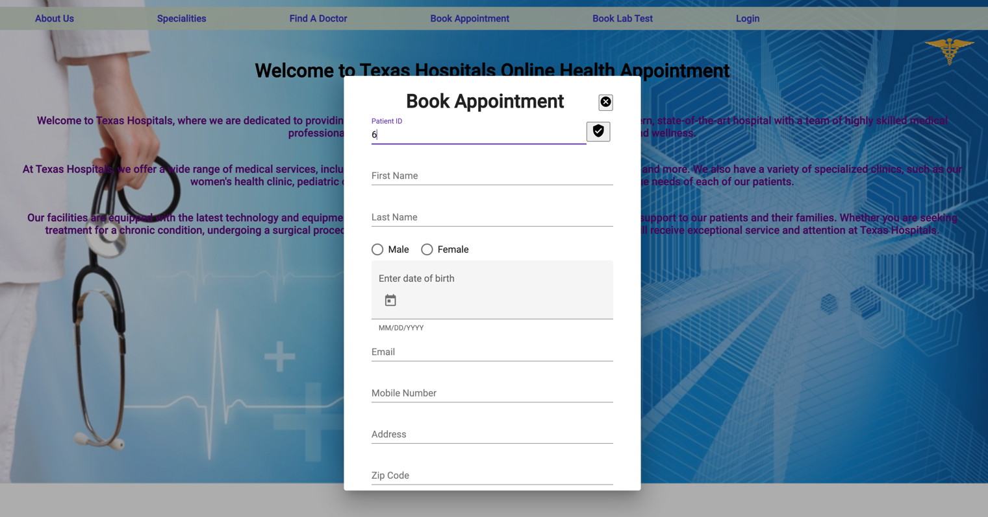

* We give the patient ID so that it fetches the data from the database

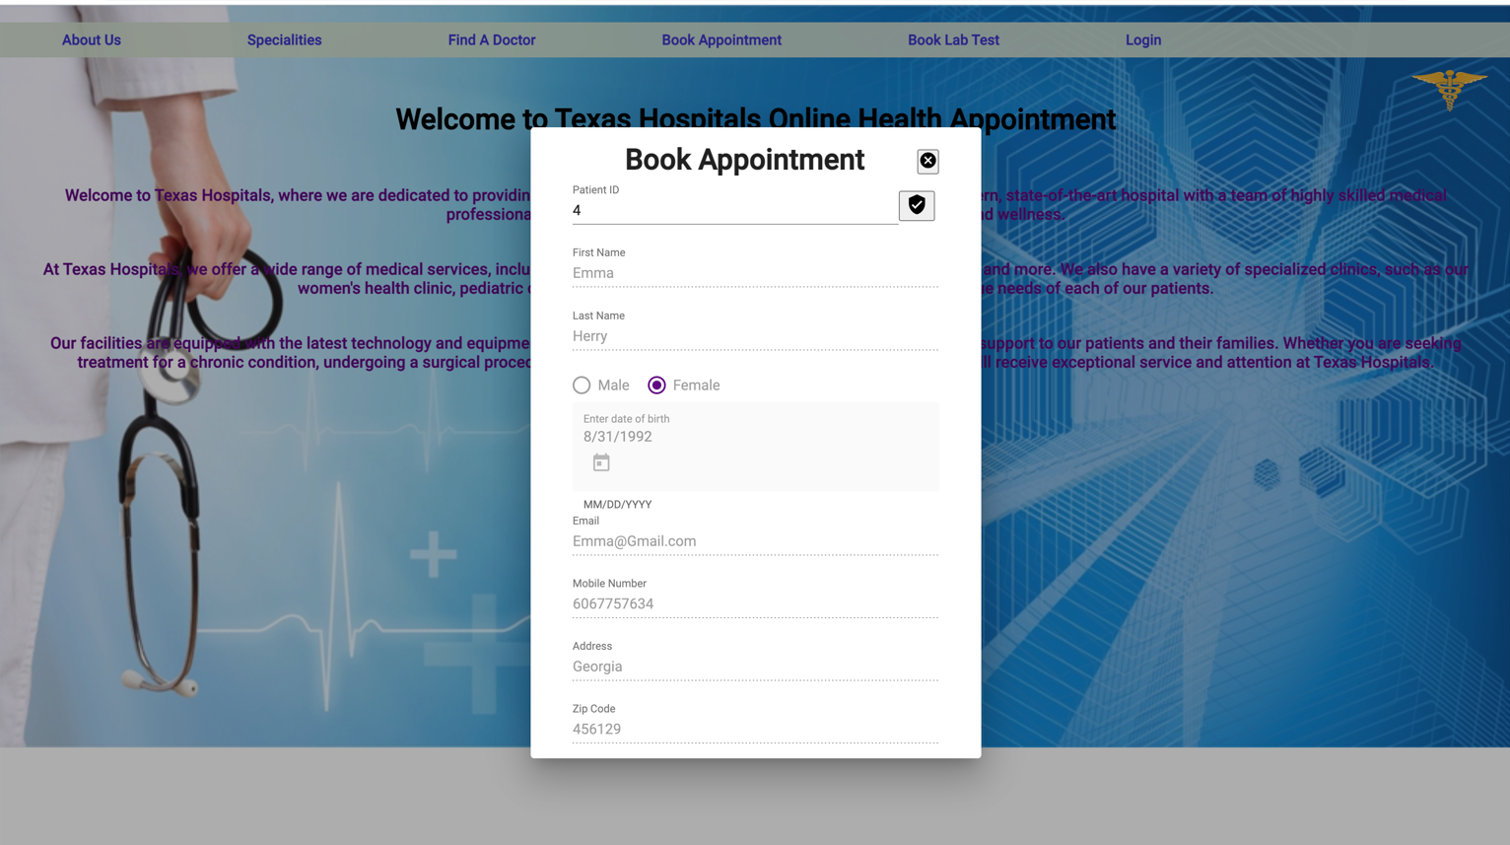

* Choosing the date to book an appointment for the available days

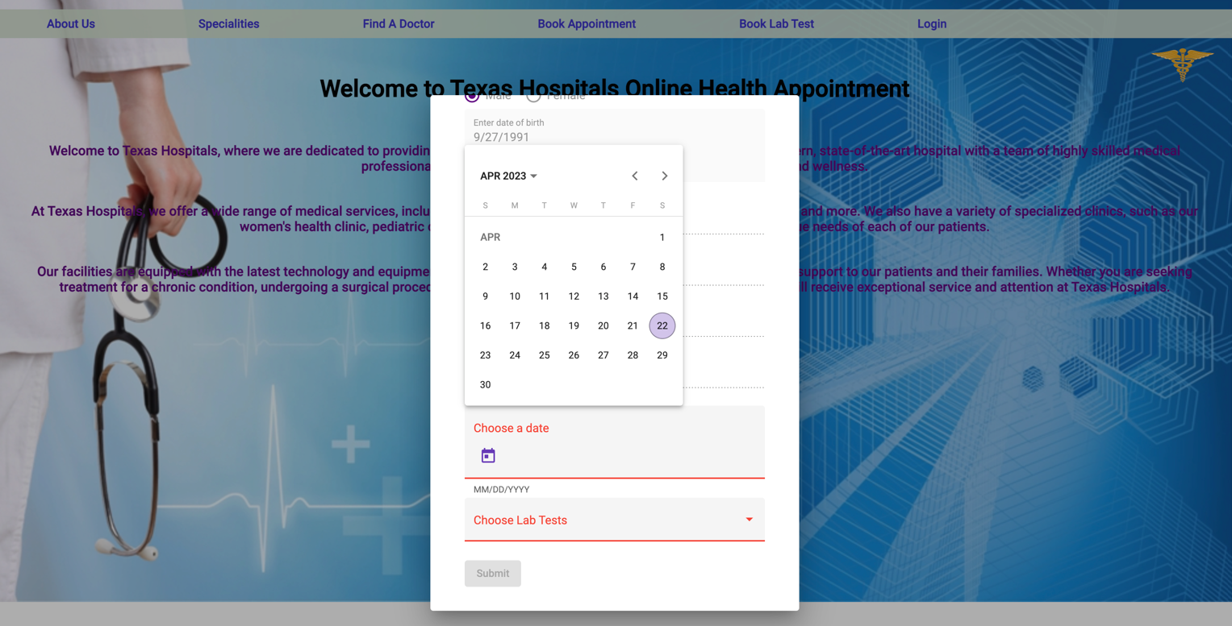

* Choosing the lab test which is prescribed by doctor

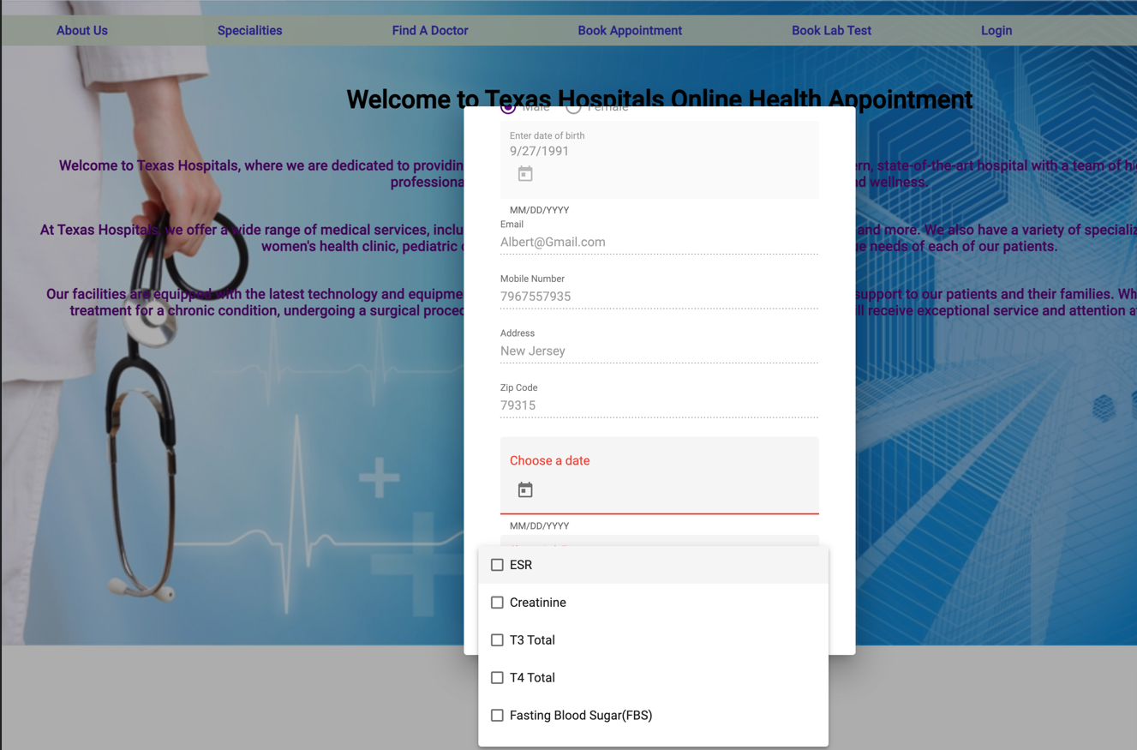

# **7. Testing**

* Existing User Page-

Scheduling appointment with existing file number user information restored.

* New User Page-

When scheduling an appointment, the new file number is generated and saved to the database.

If an existing user fills in details with the new user registration error message is generated.

* Scheduling appointment Page-

When scheduling appointments with previous dates and times they must be nullified. With all similar details email and phone number must be the same as past records.

* Schedule Medical test Page-

When scheduling a medical test with the previous date and time it must be nullified. Email and phone numbers should not be the same for different users.

* Doctors Page-

A doctor cannot have appointments for two patients at the same time.

Scheduled appointments must be displayed in the doctors’ schedule.

* Doctors/Staff Page-

Setting available times and previous dates to be nullified. Date and time must be given at setting availability for sure. Login and logout times for doctors must be different.

* Checking appointments Page-

The doctor/Staff should record the previous users. Without date entry submit not to be worked. Mandatory fields must be filled. Here are some of the Unit test cases we can perform for this healthcare portal.

* Doctor/Staff Login-While the doctor login into the portal-

Successful login-

Username: A max

Password: MaxMD

Error case-

Username: null

Password: null

Existing User-

While existing user scheduling for an appointment with correct file number-

Successful case-

File Number-123

Error case-

File number-150

# **8. Deployment diagram**

Software deployment refers to the full process of making a software system or upgrade available to the intended users.

The bulk of IT businesses and software developers now distribute software updates, fixes, and new apps using a combination of human and automated methods.

Some of the most common software deployment techniques include software release, installation, testing, deployment, and performance monitoring.

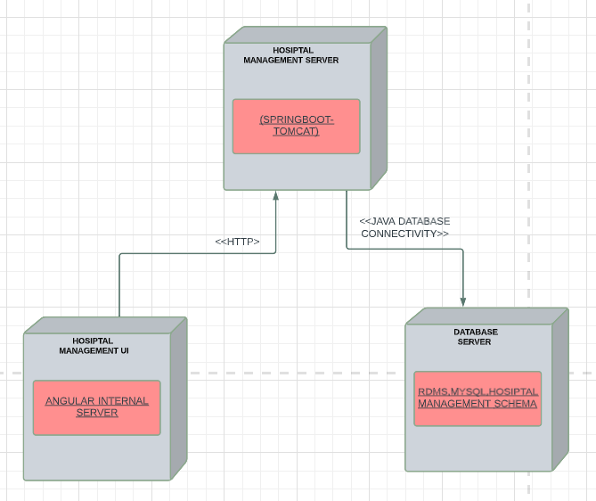

**Figure-7**

# **9. Jira Board**

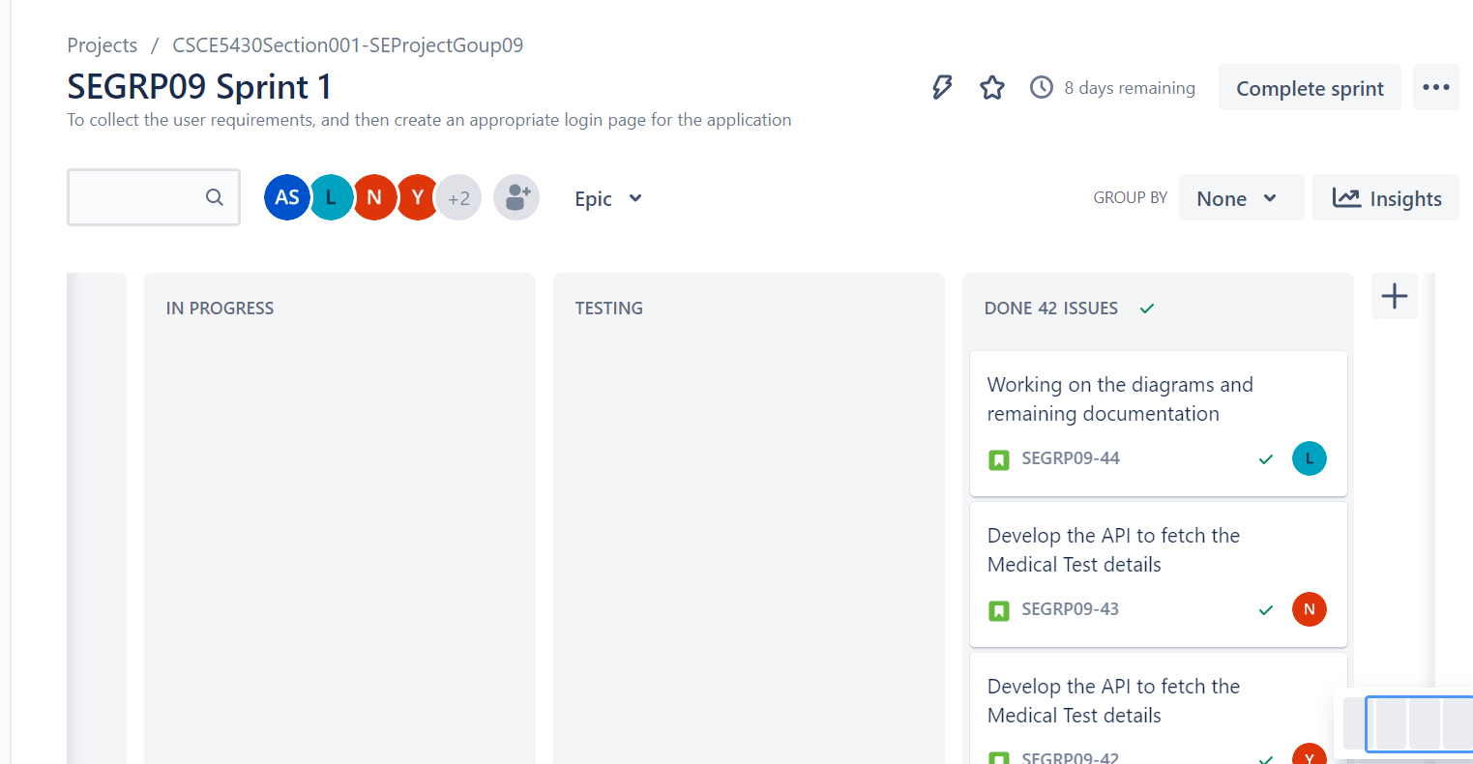

# **10.Conclusion**

With this we conclude the completion of our application to Texas Online Health Care facilities, there were issues faced in the initial phase but by following the appropriate software engineering measures we were able to resolve them. In the prototype phase, we thought to implement online payment followed by appointment scheduling but due to time constraints, we thought it adds it as an extension in the future. Apart from that, we were able to follow everything as expected by making use of the required software engineering measures.